Physics World – Part IV

An experimental 2-dimensional, physics-heavy, sandbox-game-thing.

# Submission Guidelines:

In GitHub, create a branch for your project named “Part4_Completed”.

Due at the start of our next class meeting

# Base Requirements (83)

* In GitHub, create a branch for your project named “Part4_Completed”.
* Place an annotated version of this rubric in the root directory of your Unity project. Save it in Word .docx format. When I download your Part3_Completed branch, I should find the rubric.
* Build a fully working firework rocket, and place it in your game scene.
  + The firework physics should be powered by the HomebrewRigidbody2D script
  + The firework launch and explosion should be managed by the Rocket script
  + When it explodes, the firework should create 20+ colored objects, which spread out, fall, and disappear after a few seconds.
  + Explain: In your scene, where is your firework? The firework is located in the rocket, they explode in the sky after a few seconds in the middle of the screen.
  + Explain: In your scene, when does your firework launch? It launches from two different colored rockets on the platform.
* Add detailed comments to the Rocket script, explaining how it works:
  + Use medium detail. If I were to hold on to your code and show it to Game Dev 1 students next spring, those people should be able to read your code and understand the ideas behind the code. done

# Stretch Goals:

* (+3) Prepare for, and participate in next Wednesday’s Show ‘n Tell. yes
  + Before 5PM PST next Wednesday, send me an email with one image or one **short** video from your project. You can send still image of a game scene, an image of a piece of code, or a video/gif showing a feature in action. Your choice. You pick what you want to share.
  + Be prepared to say 2-3 sentences about ONE THING from your project.
  + Say 2-3 sentences about your image in our next class meeting.
  + 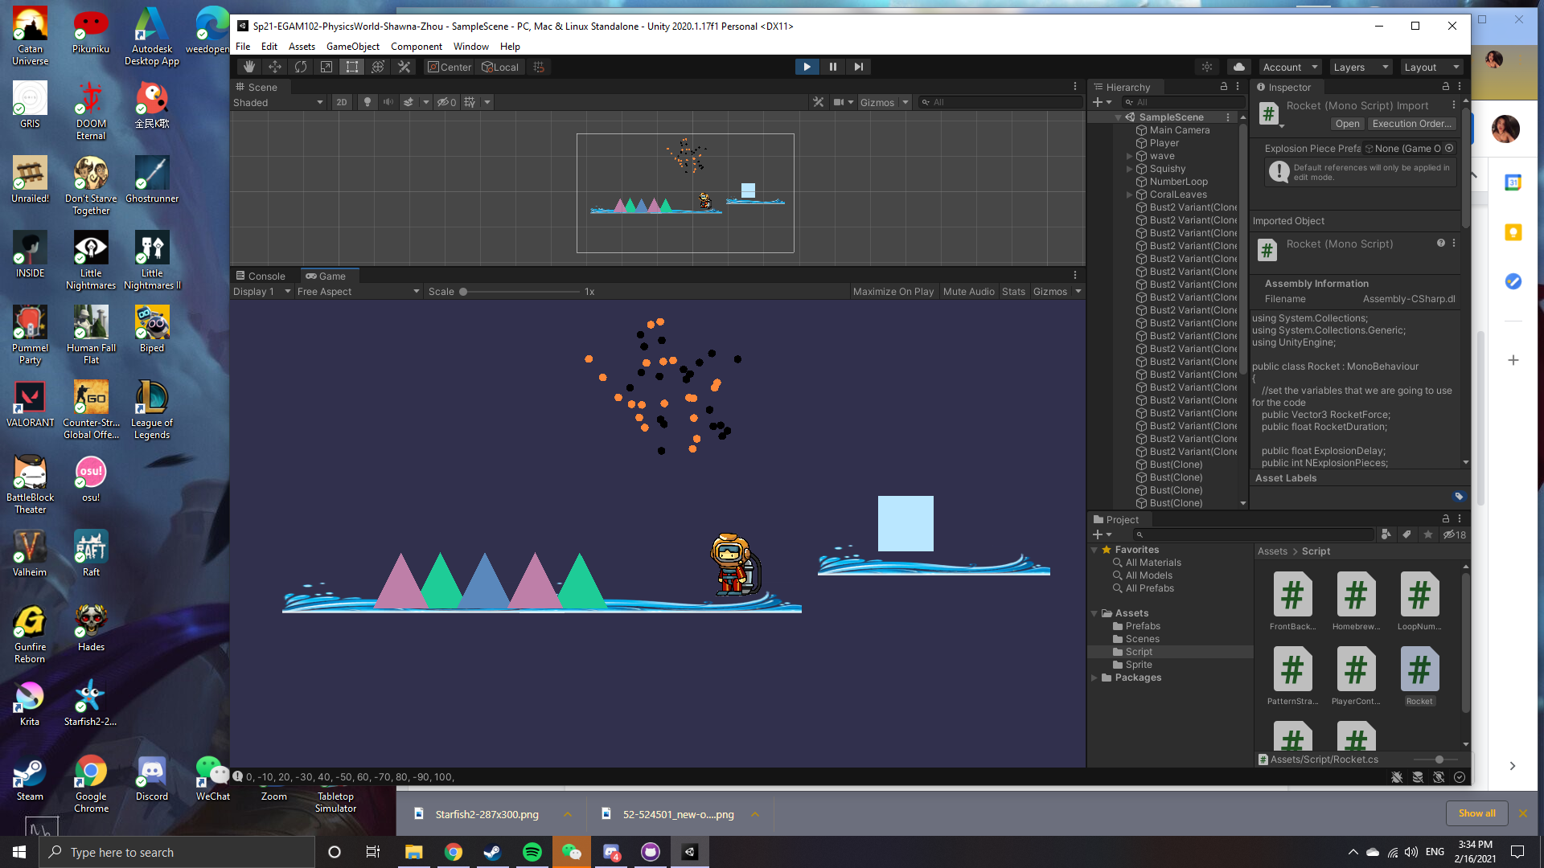
* (+1 to +10) Using words and drawings (no code, no video), create a tutorial for the basic physics of motion: position is changed by velocity, velocity is changed by acceleration, and acceleration is determined by forces.
  + Think about the things I talked about in my lecture. I used words and pictures to explain these things. My explanation was okay, and based on my understanding and my interests. You should make an explanation based on your understanding and your interests. Different people think in different ways, and so explanations that use different words can be helpful.
  + Put your tutorial in the root directory of your project, alongside the annotated rubric.
  + Your tutorial should be a .docx or .pdf file. NO PAGES FILES. (.pages are only readable on Mac)
  + If you chose to do this, write ‘yes’ here:
* (+1 to +5) Create a Sparkle script that makes explosion bits change color over time. Attach it to your explosion bit prefab, so that when your firework explodes, the explosion bits sparkle.
  + Hint: Think about the timer programming pattern. You could use this to create a script that would change the color of a sprite every X seconds. Use medium detail. If I were to hold on to your code and show it to Game Dev 1 students next spring, those people should be able to read your code and understand the ideas behind the code.
  + Explain: In your scene, where is this firework?
  + Explain: In your scene, where is this thing and when does it launch?
* (+4 to +8) Build a meta firework, and add it to your scene.
  + It should use the HomebrewRigidbody2D and Rocket scripts
  + When it explodes, it should explode into regular fireworks
  + Explain: In your scene, where is this thing and when does it launch?
* (+4 to +8) Build a meta-meta firework, and add it to your scene.
  + It should use the HomebrewRigidbody2D and Rocket scripts
  + When it explodes, it should explode into meta-fireworks
  + Explain: In your scene, where is this thing and when does it launch?
* (+10 to +30) Create a fireworks show that launches 5+ rockets in some sort of timed pattern. yes
  + Extra respect if it uses different types of fireworks. This could mean different colors of particles, or a mixture of regular fireworks, meta fireworks, etc.
  + Explain: In your scene, where is this thing and how do you start it?
  + the rocket show is located at the bottom of the game scene. They each launch and explode at a different time with different colored particles(dead fish hahaha).
* (+1 to +20) Other. Something related to this week’s topics: rockets and particles and things powered by homebrew physics.
  + Explain: What is your nifty thing?
  + Explain: Where have you used this thing in your project?